# Rossmoyne Senior High School

### Semester One Examination, 2015

### Question/Answer Booklet

**SOLUTIONS**

# MATHEMATICS 3C

## Section Two:

## Calculator-assumed

|  |  |  |  |  |  |  |  |  |
| --- | --- | --- | --- | --- | --- | --- | --- | --- |
| Student Number: In figures |  |  |  |  |  |  |  |  |

In words

Your name

## Time allowed for this section

Reading time before commencing work: ten minutes

Working time for this section: one hundred minutes

## Materials required/recommended for this section

##### *To be provided by the supervisor*

This Question/Answer Booklet

Formula Sheet (retained from Section One)

##### *To be provided by the candidate*

Standard items: pens (blue/black preferred), pencils (including coloured), sharpener,

correction fluid/tape, eraser, ruler, highlighters

Special items: drawing instruments, templates, notes on two unfolded sheets of A4 paper, and up to three calculators approved for use in the WACE examinations

## Important note to candidates

No other items may be taken into the examination room. It is **your** responsibility to ensure that you do not have any unauthorised notes or other items of a non-personal nature in the examination room. If you have any unauthorised material with you, hand it to the supervisor **before** reading any further.

## Structure of this paper

|  |  |  |  |  |  |
| --- | --- | --- | --- | --- | --- |
| Section | Number of questions available | Number of questions to be answered | Working time (minutes) | Marks available | Percentage of exam |
| Section One:  Calculator-free | 7 | 7 | 50 | 50 | 33⅓ |
| Section Two:  Calculator-assumed | 12 | 12 | 100 | 100 | 66⅔ |
|  | | | **Total** | 150 | 100 |

## Instructions to candidates

1. The rules for the conduct of Western Australian external examinations are detailed in the *Year 12 Information Handbook 2015*. Sitting this examination implies that you agree to abide by these rules.
2. Write your answers in this Question/Answer Booklet.
3. You must be careful to confine your response to the specific question asked and to follow any instructions that are specified to a particular question.
4. Spare pages are included at the end of this booklet. They can be used for planning your responses and/or as additional space if required to continue an answer.

* Planning: If you use the spare pages for planning, indicate this clearly at the top of the page.
* Continuing an answer: If you need to use the space to continue an answer, indicate in the original answer space where the answer is continued, i.e. give the page number. Fill in the number of the question that you are continuing to answer at the top of the page.

1. **Show all your working clearly**. Your working should be in sufficient detail to allow your answers to be checked readily and for marks to be awarded for reasoning. Incorrect answers given without supporting reasoning cannot be allocated any marks. For any question or part question worth more than two marks, valid working or justification is required to receive full marks. If you repeat any question, ensure that you cancel the answer you do not wish to have marked.
2. It is recommended that you **do not use pencil**, except in diagrams.
3. The Formula Sheet is **not** to be handed in with your Question/Answer Booklet.

Section Two: Calculator-assumed (100 Marks)

This section has**twelve (****12)** questions. Answer **all** questions. Write your answers in the spaces provided.

Working time: 100 minutes.

Question 8 (6 marks)

A business has been selling 420 units of a printer model each week at a price of $270 each. From past experience the business knows that for every $10 discount offered to buyers on their website, the number of units sold will increase by 20 per week.

(a) When  integer increments of the $10 discount are applied to the original printer price of $270 in a week

(i) write an expression in terms of  for the unit price. (1 mark)



(ii) write an expression in terms of  for the number of units sold. (1 mark)



(iii) show that the printer revenue function is given by .

(1 mark)



(b) Showing use of calculus, determine the maximum weekly revenue the business can achieve from sales of this printer model. (3 marks)



Question 9 (10 marks)

The rate of decay of the concentration of a pollutant measured at a particular location in a river can be modelled by the differential equation , where  is the concentration in parts per million at time , in days, and  is a constant.

(a) Given that the concentration of pollutant decreased by a factor of 10 over a period of 25 days, determine the value of  to four decimal places. (3 marks)



(b) Given that the initial concentration of the pollutant was 165 parts per million, write down an equation for  in terms of . (1 mark)



(c) Sketch the graph of  against  on the axes below. (2 marks)

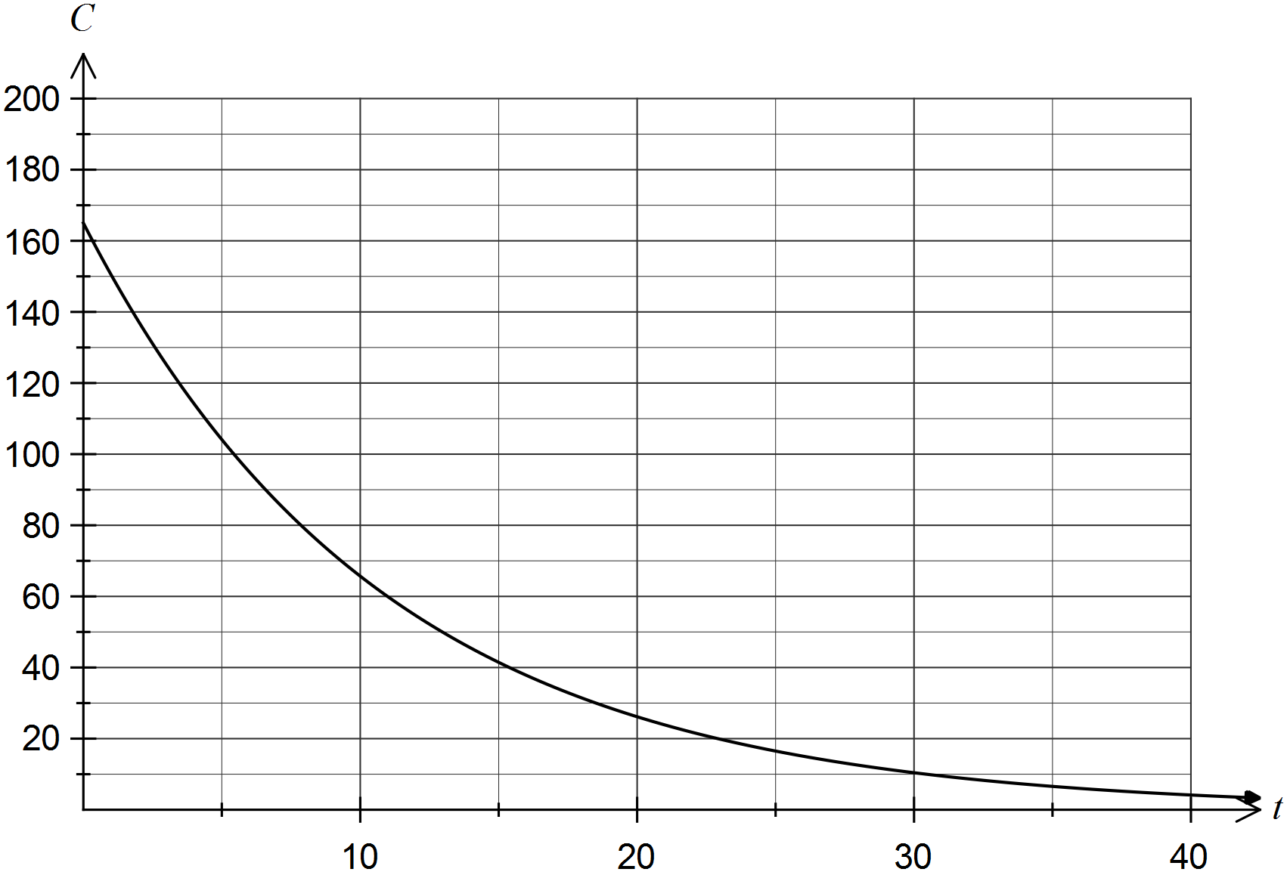

(d) The harmful effects of the pollutant are thought to become negligible after the concentration of pollutant first falls below 0.5 parts per million.

(i) Determine how many days, to the nearest day, it will take for this to occur.

(2 marks)



(ii) At this time, determine the rate that the concentration of pollutant is changing.

(2 marks)



Decreasing at 0.04605 ppm/day.

Question 10 (9 marks)

A general ellipsoid has semi-axes lengths , as shown in the diagram below and has volume given by .

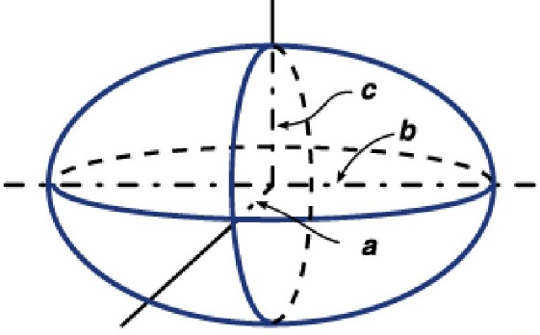

Consider the ellipsoid where the relationship between the semi-axes lengths is that  is three times , and that the sum of  and  is 42 cm.

(a) Show that the volume of this ellipsoid is given by . (2 marks)



(b) Use calculus to determine the dimensions of the ellipsoid that maximise its volume and state the maximum volume, rounded to three significant figures. (4 marks)



(c) Use the increments formula  to estimate the change in volume of the ellipsoid when  increases from 30 cm to 30.5 cm. (3 marks)



A decrease in volume of 1131 cm3.

Question 11 (9 marks)

An automated bakery produces packets of Cherry Top biscuits, a wafer coated in icing with a glace cherry on top. A minor fault of the production process means that 15% of the biscuits are double tops – they have an extra glace cherry on top.16 biscuits chosen at random from the production line are placed in each packet.

Let  be the number of double tops in a single packet of Cherry Tops.

(a) Is  a discrete or continuous random variable? Justify your answer. (2 marks)

Discrete. The only values that  can take are the integers 0, 1, 2, ..., 15 and 16.

(b) State the probability distribution of  and the mean and standard deviation of this distribution. (3 marks)



(c) Determine the probability that a randomly chosen packet of Cherry Tops

(i) contains exactly one double top. (1 mark)



(ii) contains three double tops, given that it contains at least three double tops.

(2 marks)



(d) What is the most likely number of double tops that a packet of Cherry Tops will contain?

(1 mark)

Two.

()

Question 12 (6 marks)

The job of quality control inspectors at a factory is to test components coming off an assembly line and either pass or fail them. Records indicate that the inspectors fail one out of every ten components that are not faulty, and that they pass one out of every 20 components that are faulty.

At the start of a production run for a new component, management expect one out of twelve components coming off the assembly line to be faulty.

(a) Determine the exact probability that the inspectors will fail a randomly chosen component coming off the assembly line. (3 marks)



(b) Given that the inspectors pass a component, calculate the exact probability that the component is actually faulty. (3 marks)



Question 13 (9 marks)

(a) Let .

(i) Evaluate . (1 mark)



(ii) Explain what happens to the value of  as . (2 marks)

As  increases the value of .

(b) If ,  and 

(i) use the chain rule with Liebniz notation to determine , giving your answer solely in terms of . (4 marks)



(ii) determine the value of  when . (2 marks)



Question 14 (8 marks)

For two events,  and , ,  and .

(a) Determine an expression for  in terms of . (2 marks)



(b) Determine . (1 mark)



(c) Determine the value of  under each of the following conditions.

(i) . (1 mark)



(ii) . (2 marks)



(iii)  and  are independent. (2 marks)



Question 15 (10 marks)

As part of a local arts festival, an artist plans to create an installation in which a concealed water cannon blasts a stream of water into the air for a few seconds at random intervals. At the start of each day of the festival, the reservoir for the cannon will be filled with enough water for 15 firings.

The lengths of the intervals between each firing of the cannon can be modelled by the uniformly distributed random variable , where  minutes.

(a) Sketch the probability density function  for the interval between each firing on the axes below. (2 marks)

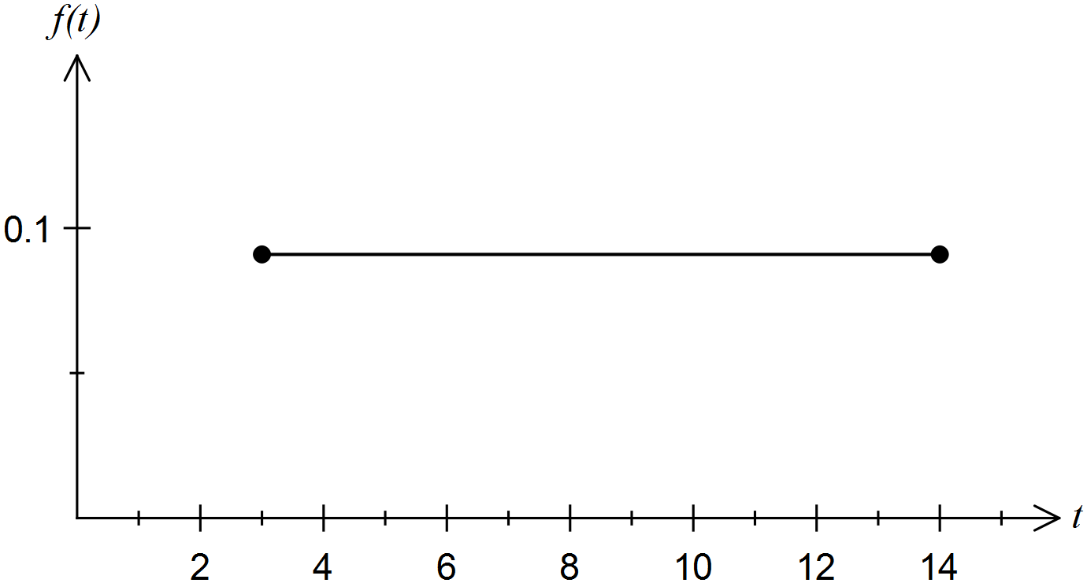

(b) Determine the probability that a randomly chosen interval between firings is

(i) at least seven minutes. (1 mark)



(ii) at least six minutes given that it is less than 10 minutes. (2 marks)



(c) If the water cannon is fired 15 times per day, how many intervals will there be between these 15 blasts? (1 mark)

15 firings, so 14 intervals.

(d) Determine the probability that, on any one day of the festival, five or more intervals will be less than seven minutes long. (2 marks)



(e) Determine the value of  for which . (2 marks)



Question 16 (8 marks)

The graph of the function  is shown below over the domain .

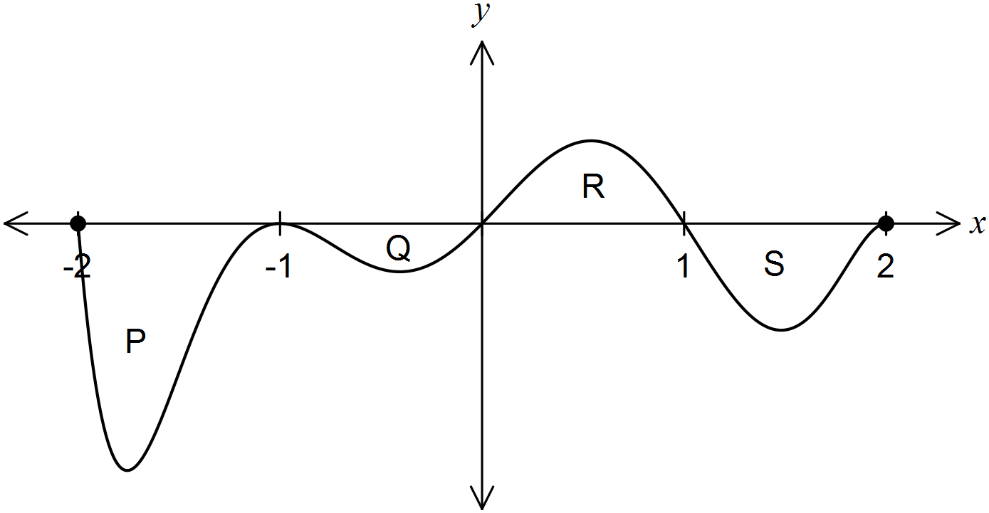

The areas of regions P, Q, R and S enclosed by the curve and the -axis are 5, 1, 2 and 3 square units respectively.

(a) Determine the area enclosed by the curve and the -axis for . (1 mark)



(b) Determine the value of

(i) . (2 marks)



(ii) . (2 marks)



(iii) . (3 marks)



Question 17 (9 marks)

(a) Records of a company that has a large workforce indicate that 35 percent of employees take sick leave during any given year.

If the records of five employees are selected at random from the previous year, what is the probability that

(i) exactly four of the five took sick leave? (2 marks)



(ii) fewer than three took sick leave? (2 marks)



(b) Amongst the 20 management staff of the company, seven of them had taken sick leave during the previous year.

If five of these staff are selected at random, what is the probability that

(i) two or less took sick leave? (3 marks)



(ii) none of the staff took sick leave, given that two or less took sick leave? (2 marks)



Question 18 (9 marks)

A bakery packages a loaf of bread as a standard if it weighs between 450 g and 500 g. The weights of all loaves produced by the bakery are normally distributed with a mean of 470 g and a standard deviation of 16 g.

(a) What is the probability that a randomly selected loaf produced by the bakery

(i) weighs 450 g? (1 mark)



(ii) is a standard loaf? (1 mark)



(b) Determine the probability that a randomly selected standard loaf weighs less than 470 g.

(2 marks)



(c) In a batch of 250 loaves, how many would be expected to weigh less than a standard loaf? (2 marks)



(d) Calculate the interquartile range of the weights of standard loaves from the bakery.

(3 marks)

Standard loaves comprise 86.4% of production.



Question 19 (7 marks)

Let ,  and , where  is a positive real constant. The graphs of  and  are shown on the axes below.

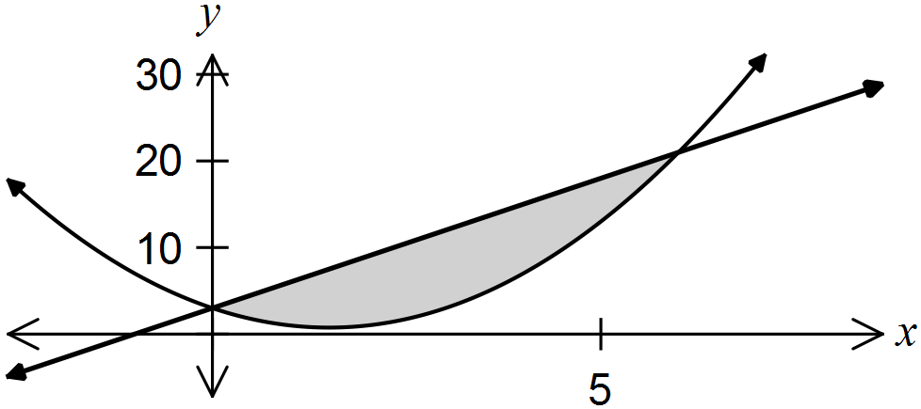

(a) Write down an integral that, if evaluated, would calculate the shaded area trapped between the graphs of  and . (2 marks)



(b) Show that the graphs of  and  intersect when  and .

(2 marks)



(c) The area trapped between the graphs of  and  is 972 square units. Determine the value of . (3 marks)

Using CAS:



Additional working space

Question number: _________

This examination paper may be freely copied, or communicated on an intranet, for non-commercial purposes within educational institutes that have purchased the paper from WA Examination Papers provided that WA Examination Papers is acknowledged as the copyright owner. Teachers within Rossmoyne Senior High School may change the paper provided that WA Examination Paper's moral rights are not infringed.

Copying or communication for any other purposes can only be done within the terms of the Copyright Act or with prior written permission of WA Examination papers.

*Published by WA Examination Papers*

*PO Box 445 Claremont WA 6910*